Name: Muhammad Masood Khan

Reg-No: FA21-BSE-028

**LAB - PACKAGE DIAGRAM**

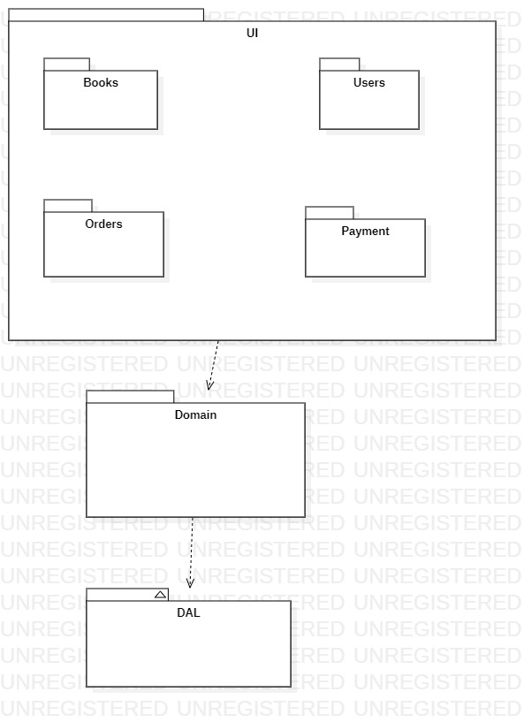

**On page:**

